- Go to https://repository.qsartoolbox.org/
- Log in with the same settings which are used for downloading QSAR Toolbox
- Click on a module (e.g. ECHA plugin) and download it. Do this with all modules you need.
- Open Toolbox.
- Go to the Options>>Modules and click Start QSAR Toolbox Repository client
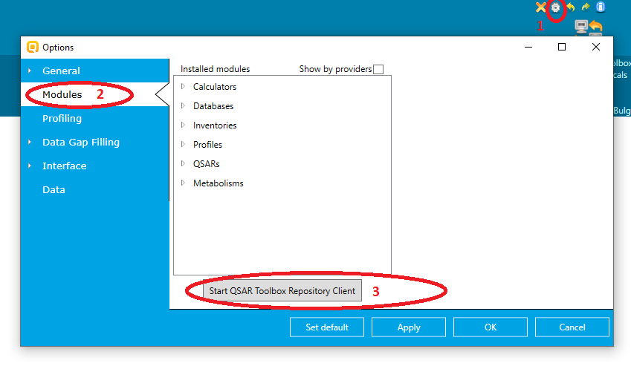

- Click Load from file and load the downloaded file*
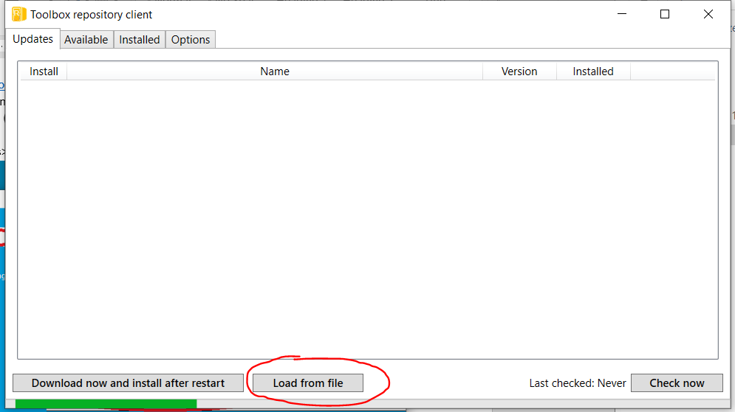

- Do this with all files you have downloaded.
- Close Toolbox (the server and the client) and open them again

*Note: If you are loading the KATE module, you will be asked to enter a login name and password. Follow the link and define your settings. After that read and agree the terms of agreement and save the settings.
